**System Reference Guide**

**Introduction**

Welcome to the System Reference Guide and Documented Tests for the web site from Task 1. This comprehensive internal documentation provides a detailed understanding of the application's construction, functionality, and testing procedures, enabling seamless project takeover, support, enhancement, and development.

The system reference guide offers valuable insights into the application's design and development, including the analysis and user-centred design process. It highlights the rationale behind the site's structure and functionality, empowering colleagues to contribute effectively to ongoing development, provide support, address bugs, and implement enhancements.

Our documentation emphasizes the importance of achieving effective code coverage to ensure a robust and bug-free system. The guide follows a structured format, offering an introduction, detailed breakdown of analysis and design, a full list of web pages with descriptions, a page structure diagram, and screenshots for visual reference.

Additionally, the documentation includes a data dictionary, detailing the application's database tables and field specifications. Process descriptions provide explanations of key PHP programs, while sample code snippets offer references for complex elements. Screenshots of developed tests and test logs demonstrate the thoroughness and effectiveness of the testing process.

By following this structured guide, colleagues will have the knowledge and resources necessary to support, enhance, and maintain the web site from Task 1 effectively.

**Analysis and User-Centred Design**

**Font styling**

To ensure an optimal user experience, default font styling has been carefully selected, considering the effectiveness of popular fonts. These fonts have gained popularity for their widespread usage and familiarity, allowing users to feel comfortable and at ease while browsing the website. By employing adaptive font choices, the website ensures seamless compatibility across various devices.

In the absence of explicitly defined fonts, the following list of fonts is utilized: "system-ui, -apple-system, 'Segoe UI', Roboto, 'Helvetica Neue', 'Noto Sans', 'Liberation Sans', Arial, sans-serif, 'Apple Color Emoji', 'Segoe UI Emoji', 'Segoe UI Symbol', 'Noto Color Emoji'." Through extensive testing during development, it has been observed that on most devices, the fallback font eventually resolves to the sans-serif typeface. This font choice holds considerable advantages in terms of readability and legibility.

By prioritizing these font selections, the website aims to create an aesthetically pleasing environment for users, ensuring a visually engaging and comfortable browsing experience across a variety of devices.

**Font sizing**

Font sizing played a crucial role in the overall design considerations of the website. Extensive research has indicated that maintaining a font size of 16 pixels is a widely recommended guideline for mobile websites. This size strikes a balance between ensuring readability for visually impaired readers and preventing excessive difficulty in reading. As Scacca (2018) suggests, finding the perfect font size is akin to the Goldilocks principle, where 16 pixels consistently proves to be an optimal choice.

To adhere to these principles, font sizes on the website have been carefully implemented, with none smaller than 16 pixels. In fact, most font sizes have been set to a minimum of 18 or 20 pixels. This deliberate decision ensures that content remains legible and accessible across various devices and screen sizes.

Additionally, a standardized approach has been adopted to maintain uniformity across all pages. This consistency in font sizes enhances the overall visual coherence of the website, providing a seamless and pleasant reading experience for users. By following these guidelines, the website prioritizes both readability and aesthetics, striking the right balance for optimal font sizing.

**Colours**

For optimal readability and accessibility, extensive testing using Adobe Colour accessibility tools was conducted for colour selection on the website.

After careful consideration, a dark blue colour (#020077) was chosen as the core primary colour, complemented by a light grey background (#F2F2F2). This combination successfully passed the contrast ratio test with a score of 14.78:1, meeting the recommended accessibility guidelines.

To enhance visual appeal and create a sense of sophistication, a dark red colour (#910012) was selected to accompany the dark blue. This colour choice, when applied on the light grey background, also passed the contrast test with a score of 8.48:1, ensuring clear legibility.

By conducting thorough colour accessibility tests and adhering to contrast ratio guidelines, the website strikes a balance between aesthetics and readability. The dark blue and dark red colours create a visually engaging and luxurious atmosphere, while the light grey background ensures that the text and content are easily readable for all users.

**Background**

We have chosen a carefully curated image of a cityscape with a dark overlay for our car sales website. This design choice offers several benefits: it creates an immersive and dynamic atmosphere, evokes urban energy, and taps into the aspirational nature of car ownership. The dark overlay enhances the visibility of white headings, ensuring easy readability against the visually complex background. Additionally, it directs the user's focus towards the light grey content containers, optimizing information absorption and facilitating a streamlined browsing experience. This intentional design approach emphasizes key details, such as vehicle listings and calls-to-action, while maintaining a visually compelling and sophisticated aesthetic. Overall, the cityscape image with a dark overlay enhances visual appeal, readability, and user engagement on our website.

**Content layout**

The content layout on all pages has been thoughtfully structured to avoid overwhelming the users and to guide their attention towards the key elements of each page. This intentional design approach ensures a seamless user experience and effective communication of important information.

Research conducted by Nielsen Norman Group (Gordon, 2020), a leading authority in user experience, emphasizes the significance of content prioritization and attention guidance. By organizing the content strategically, we create a hierarchy that directs users' focus towards the intended focal points on the page.

Through careful placement, size, and visual cues, we highlight crucial elements such as calls-to-action, product features, and important details. By minimizing distractions and optimizing the visual weight of these elements, we enhance their visibility and make them stand out.

Additionally, whitespace and proper spacing are employed to create a sense of visual balance and improve content legibility. This approach helps users digest information more easily, without feeling overwhelmed by a cluttered layout.

By implementing a user-centred content layout, we ensure that users can quickly and intuitively navigate the website while focusing on the most relevant aspects. This enhances user engagement, facilitates information absorption, and ultimately contributes to a positive user experience.

**Buttons and Navigation**

The website employs several techniques to enhance the user experience and streamline navigation. Key features, such as pagination, appropriately sized buttons, and ample spacing, have been carefully incorporated to ensure ease of use and efficiency.

Pagination allows users to navigate through content in a structured and organized manner. By breaking up information into manageable sections, users can easily browse through different pages, improving accessibility and reducing cognitive load.

Appropriately sized buttons play a crucial role in facilitating user interactions. By providing buttons that are visually prominent and comfortably clickable, users can intuitively perform actions, such as submitting forms, or navigating to different sections of the website. This improves the overall usability and efficiency of the website.

Sufficient spacing between elements ensures a visually pleasing and uncluttered layout. Ample whitespace helps to create a sense of separation between different content components, preventing visual overload and allowing users to focus on individual elements. It also improves readability and touch interactions, particularly on mobile devices, by reducing the chance of accidental taps or clicks.

By incorporating these elements into the website design, we aim to optimize the user experience, making navigation intuitive, interactions seamless, and content consumption efficient.

**Images and Data**

In a departure from the conventional approach, the car sales website deviates from the typical reliance on images as the core content. This decision was influenced by the client's specifications, which allowed for the creation of new database records but restricted modifications to the associated fields. Consequently, the inclusion of images for vehicles became impractical within these limitations.

To address this challenge, alternative image sources such as Google Images could have been utilized. However, concerns arose regarding content moderation, as there was a risk of inappropriate or irrelevant images inadvertently appearing on the website. Consequently, the decision was made to forego the use of images for cars altogether. It is worth noting that this limitation presents an opportunity for future implementation and enhancement.

While the absence of images may be seen as a limitation, it has the advantage of mitigating potential issues with slower loading speeds. By minimizing the reliance on image-heavy content, the website ensures optimal performance and a smoother user experience.

Moving forward, the inclusion of images can be considered as part of future updates or enhancements to the website, enabling the visual enrichment of vehicle listings. However, the current approach focuses on providing comprehensive and relevant information without compromising performance or risking inappropriate content.

By carefully navigating the limitations imposed by the client brief, the website strikes a balance between functionality, content integrity, and efficient performance.

**Web Pages**

**Home / Index**

The Home page welcomes users to the website with a clear heading and informative text. It serves as the initial introduction to the website's design and brand identity, setting the stage for user engagement. As the title may suggest, it is the welcoming page to the website, it consists of a simple heading and some text under it to welcome the user. Upon coming onto this page, the user is introduced to the websites design and brand identity.

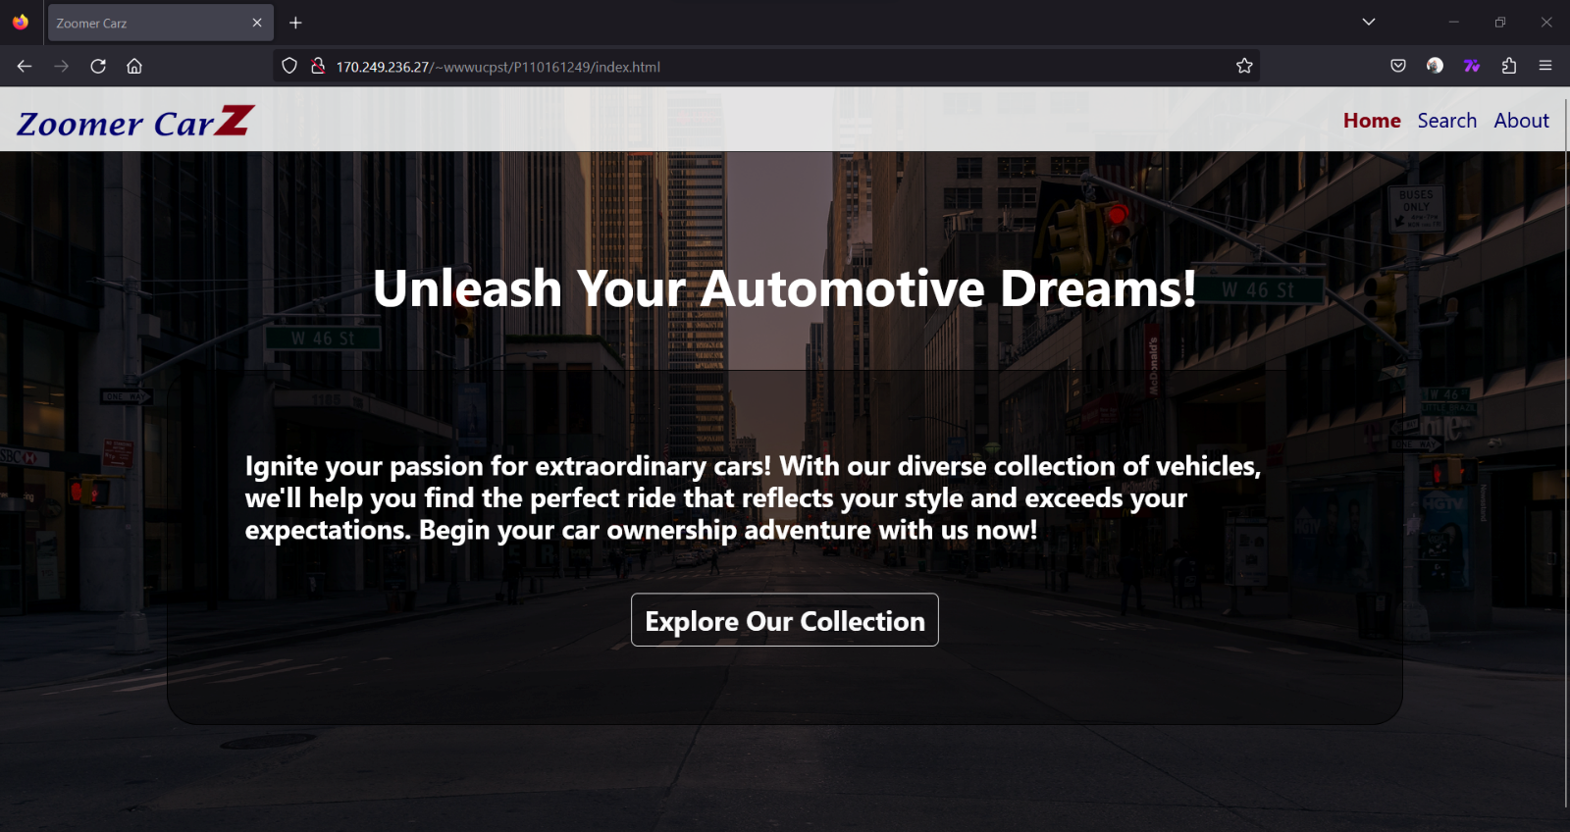**Figure 1**. Image of the home page as it is loaded on a Mozilla Firefox browser.

**Main Search Page**

The main search page is designed to maximize user efficiency and enhance the overall experience. It achieves this through the integration of a well-developed pagination system and intuitive filtering interactions. Positioned at the bottom, the pagination feature allows users to effortlessly navigate through the search results, quickly reaching the desired content without any obstacles. This streamlined approach not only saves valuable time but also ensures a seamless and efficient user experience.

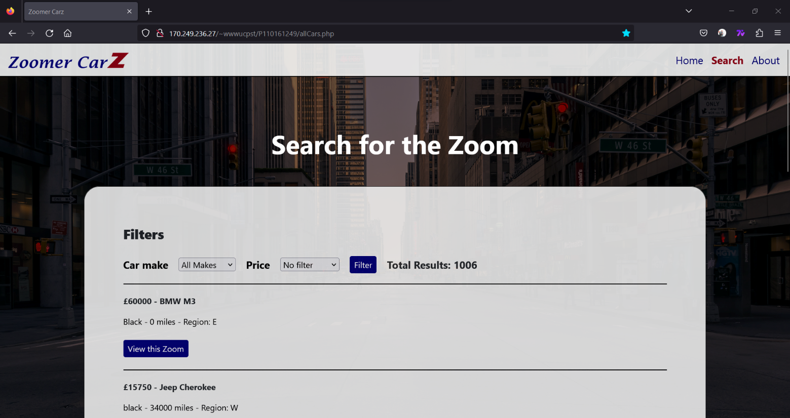**Figure 2.** Image of the main search page as it is loaded on a Mozilla Firefox browser.

**Figure 3**. Image of the main search page’s pagination design loaded on a Mozilla Firefox browser.

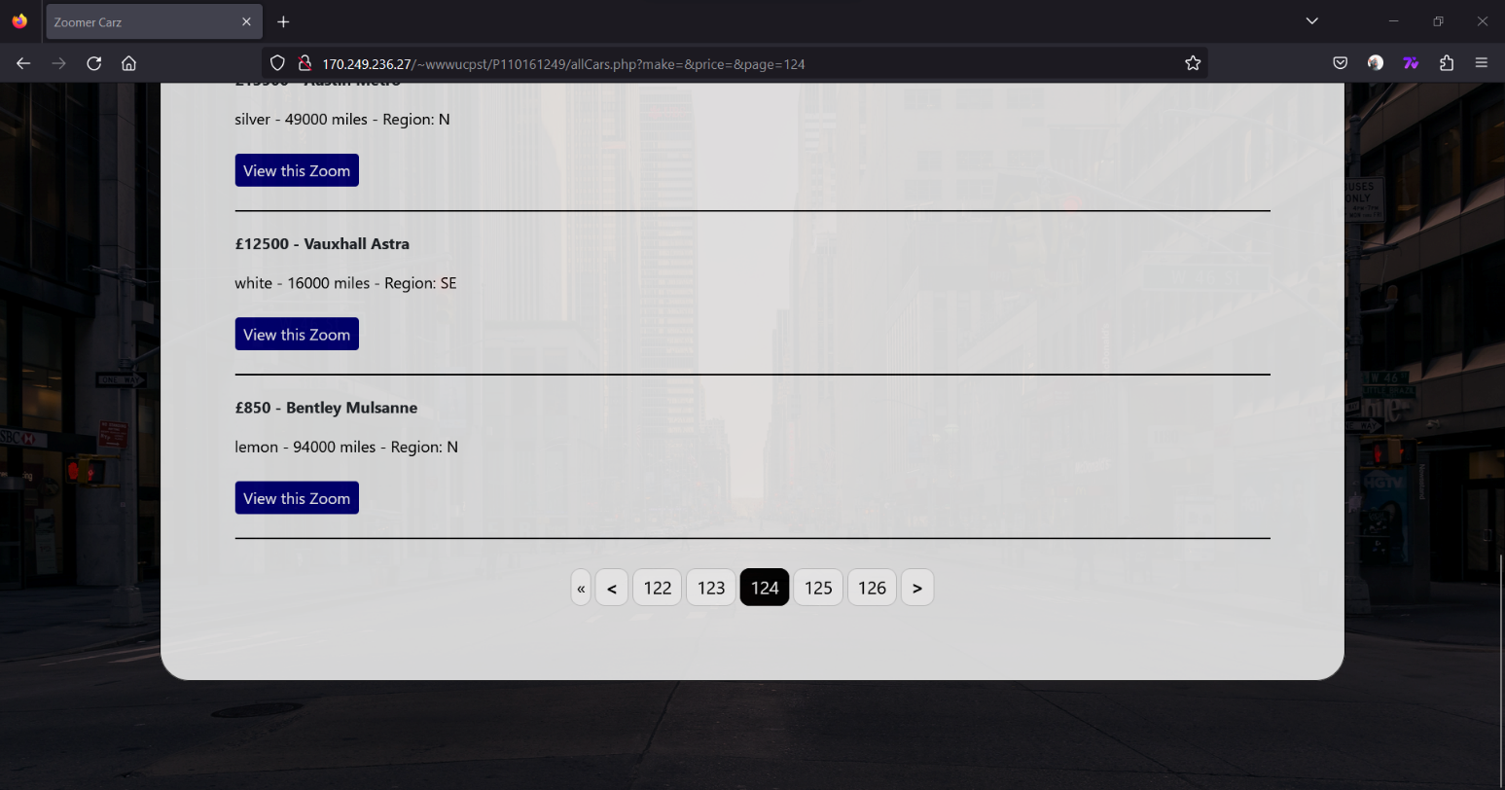

**Single Vehicle**

This page follows the user’s request to view a vehicle from the search page, it displays the vehicle, dealer and location details and allows the user to purchase the vehicle.

**Figure 4.** An image to show the single vehicle page as it is loaded on a Mozilla Firefox browser.

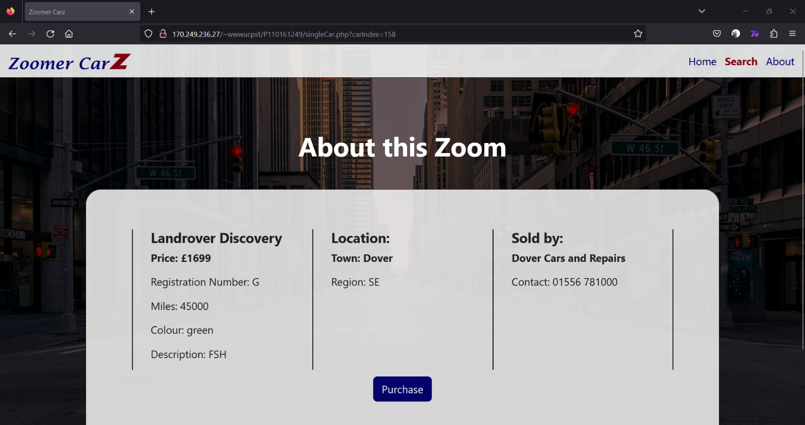

**Purchase**

The purchase page follows the users request to purchase the vehicle from the single vehicle page. It displays the vehicle information and two form fields (customer details and payment details) followed by a submit button to submit a purchase request.

**Figure 5.** This image depicts the purchase page scrolled down to reveal the complete 'core' form content. The navigation is still accessible, it is temporarily hidden from view as the page is scrolled down.

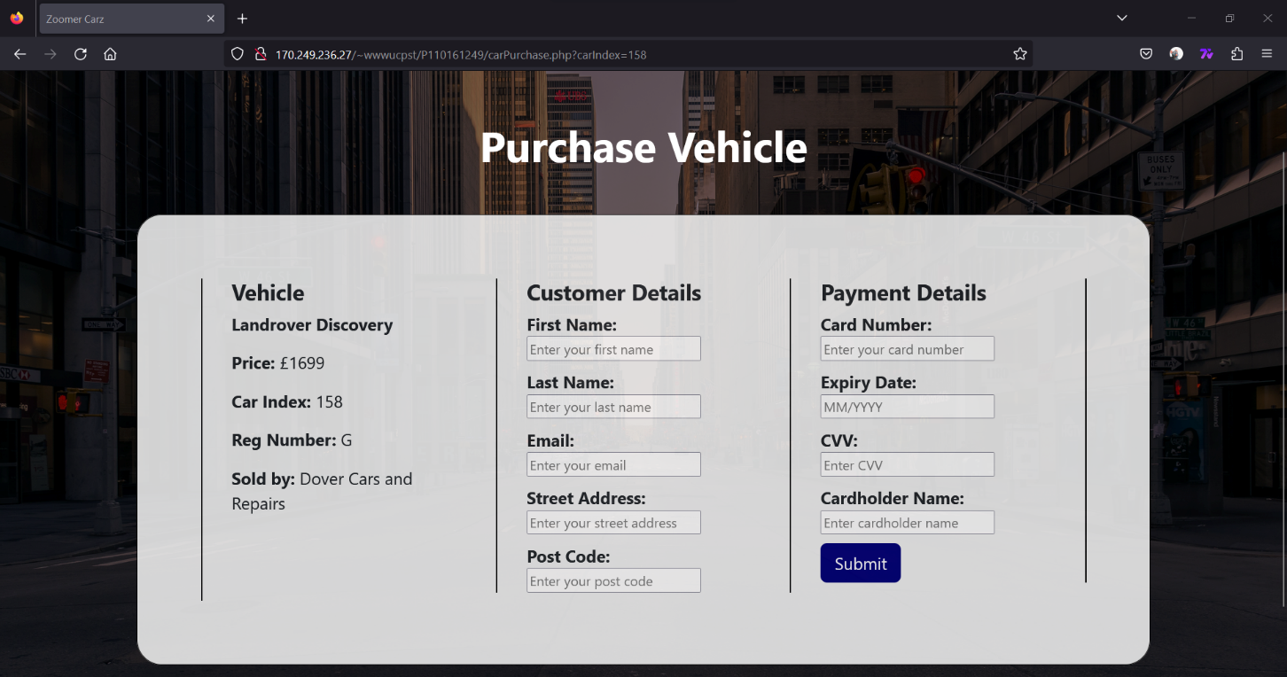

**Purchase confirmation**

The purchase confirmation page follows on after the purchase page when the user clicks the submit button. It presents the user with an order number and a thank you message and information on the next steps in the purchasing process.

**Figure 6.** This image shows the purchase confirmation page scrolled down to reveal the complete 'core' form content. The navigation is still accessible just like on every page; it is temporarily hidden from view as the page is scrolled down.

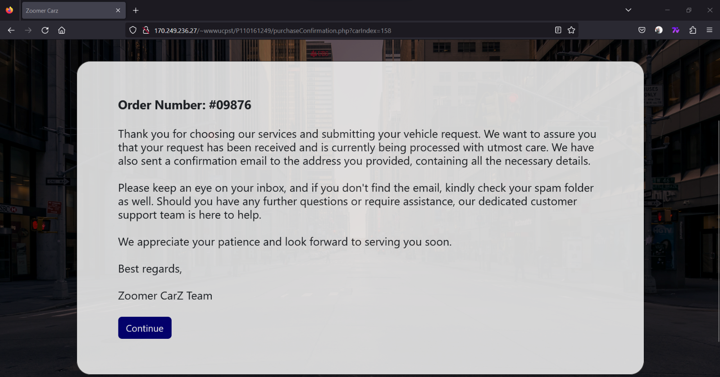

**About page**

The about page acts as an informative page set out to introduce the user to the company goals, values. It also hides a secret admin login button at the bottom left of the page.

**Figure 7.** An image to show the about page’s first portion of the page, loaded on a Mozilla Firefox browser.

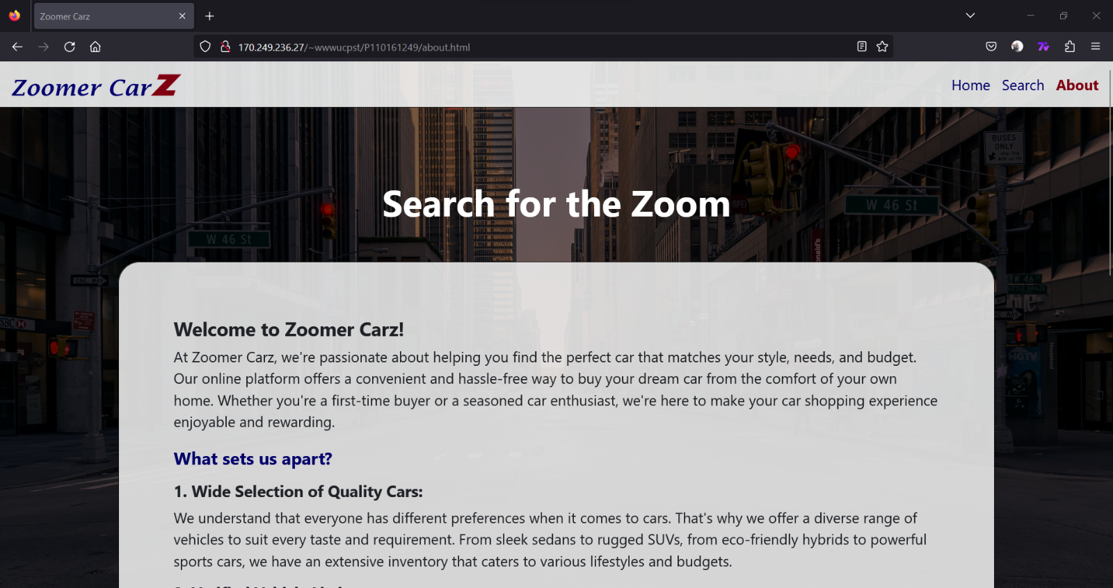

**Figure 8.** An image to show the second portion of the about page loaded on a Mozilla Firefox browser.

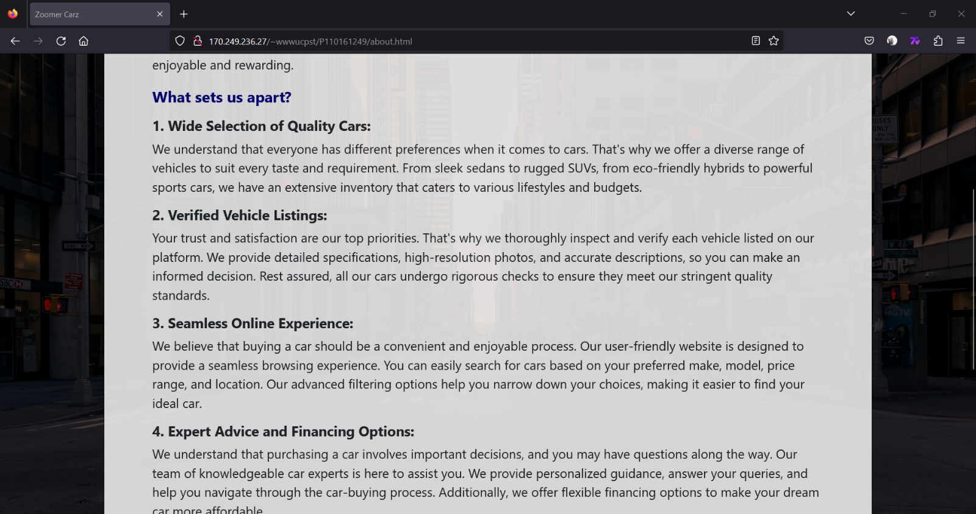

**Figure 9.** An image to show the final part of the about page loaded on a Mozilla Firefox browser.

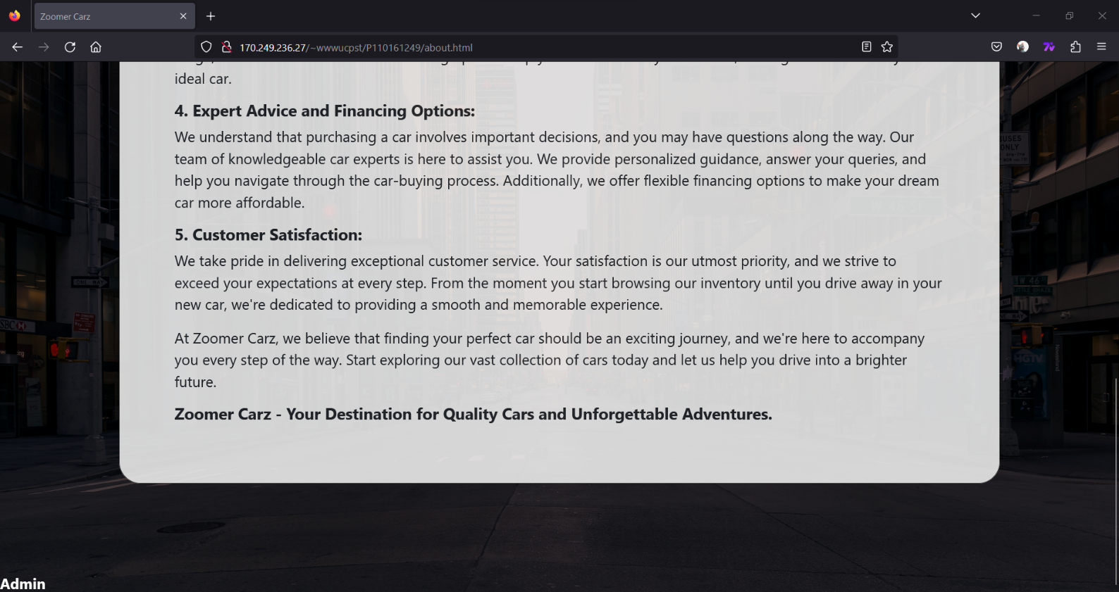

**Admin login**

The admin page is a follow up from the user clicking on the admin link at the bottom of the about page. This page displays a generic login screen for the admins to enter their credentials.

**Figure 10.** An image to show the admin login screen loaded on a Mozilla Firefox browser.

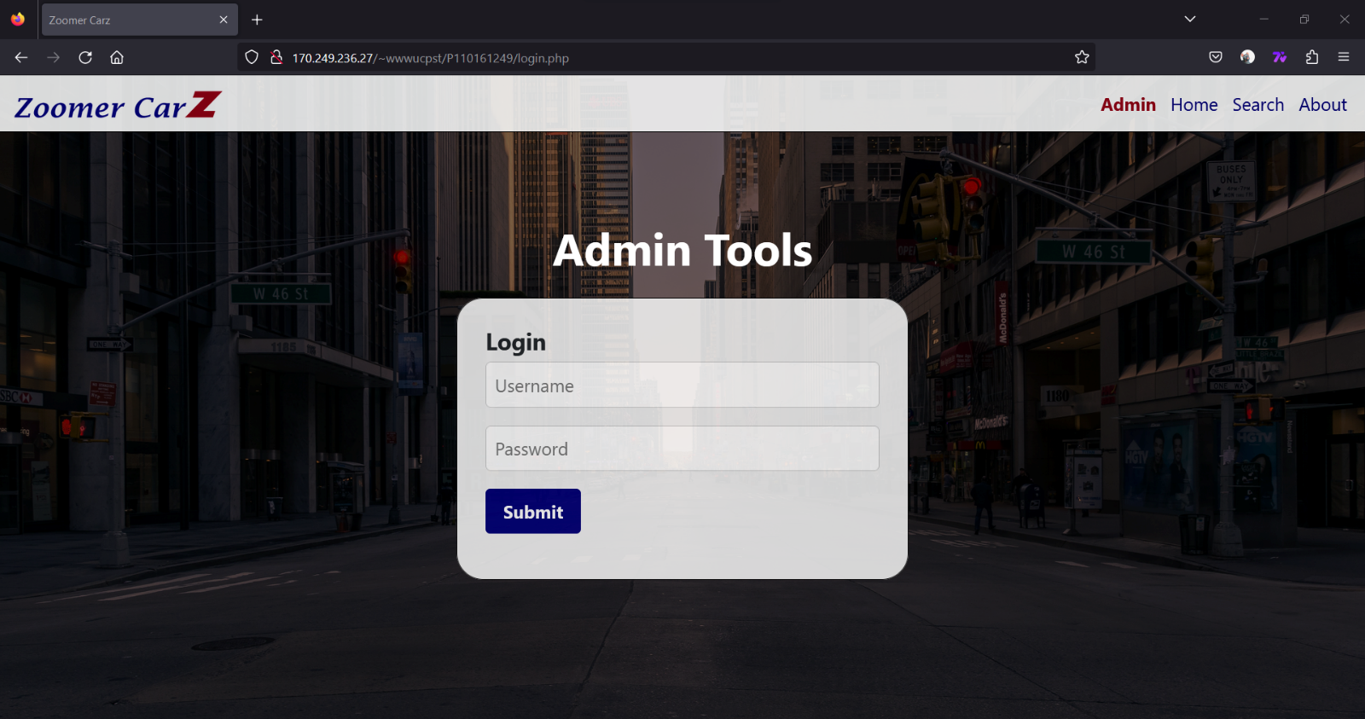

**Main admin**

The main admin page follows on from the admin login page. It shows the various admin tools without them being open. There are three database edit tools, add, remove and modify/edit, there is also a logout button at the bottom of the options list.

**Figure 11.** An image to show the admin main page, loaded on a Mozilla Firefox browser.

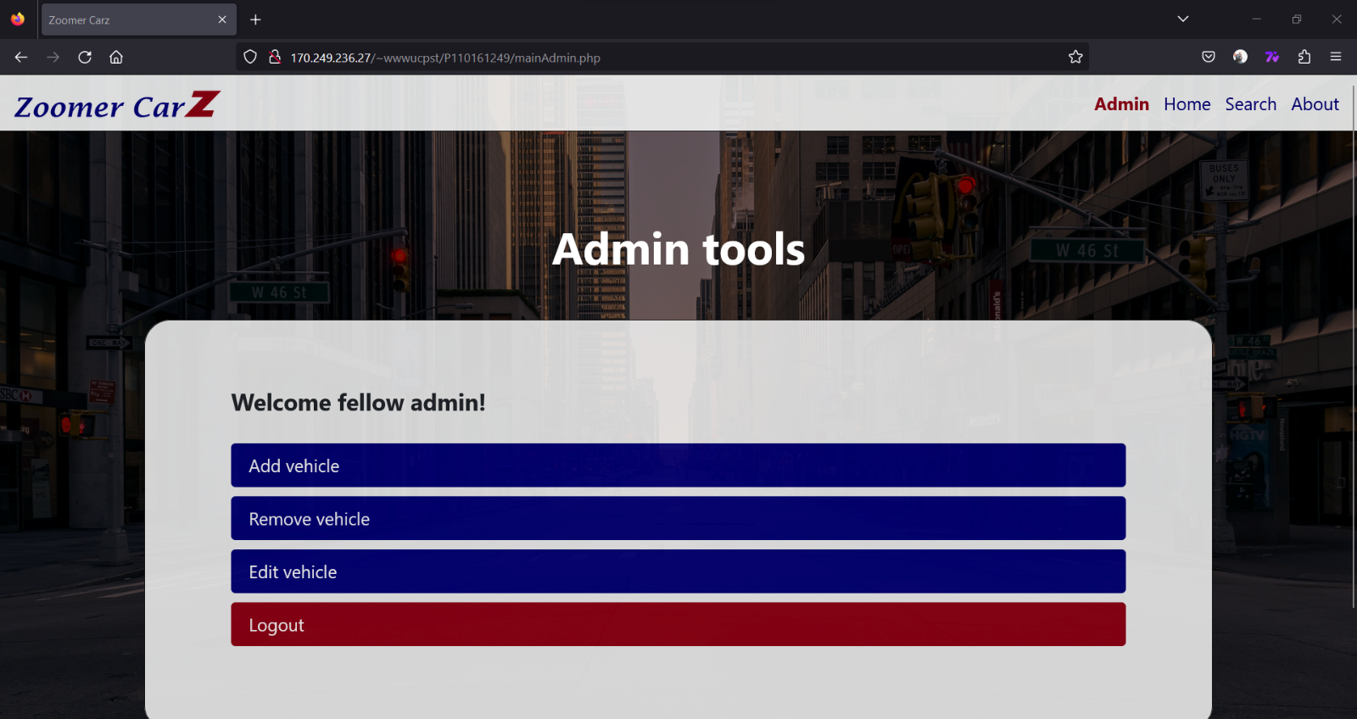

**Add Vehicle**

The add vehicle provides a form for the admins to fill out and a submit button to complete the application and send the request to the database for processing.

**Figure 12.** An image to show the first portion of the add vehicle page loaded on a Mozilla Firefox browser.

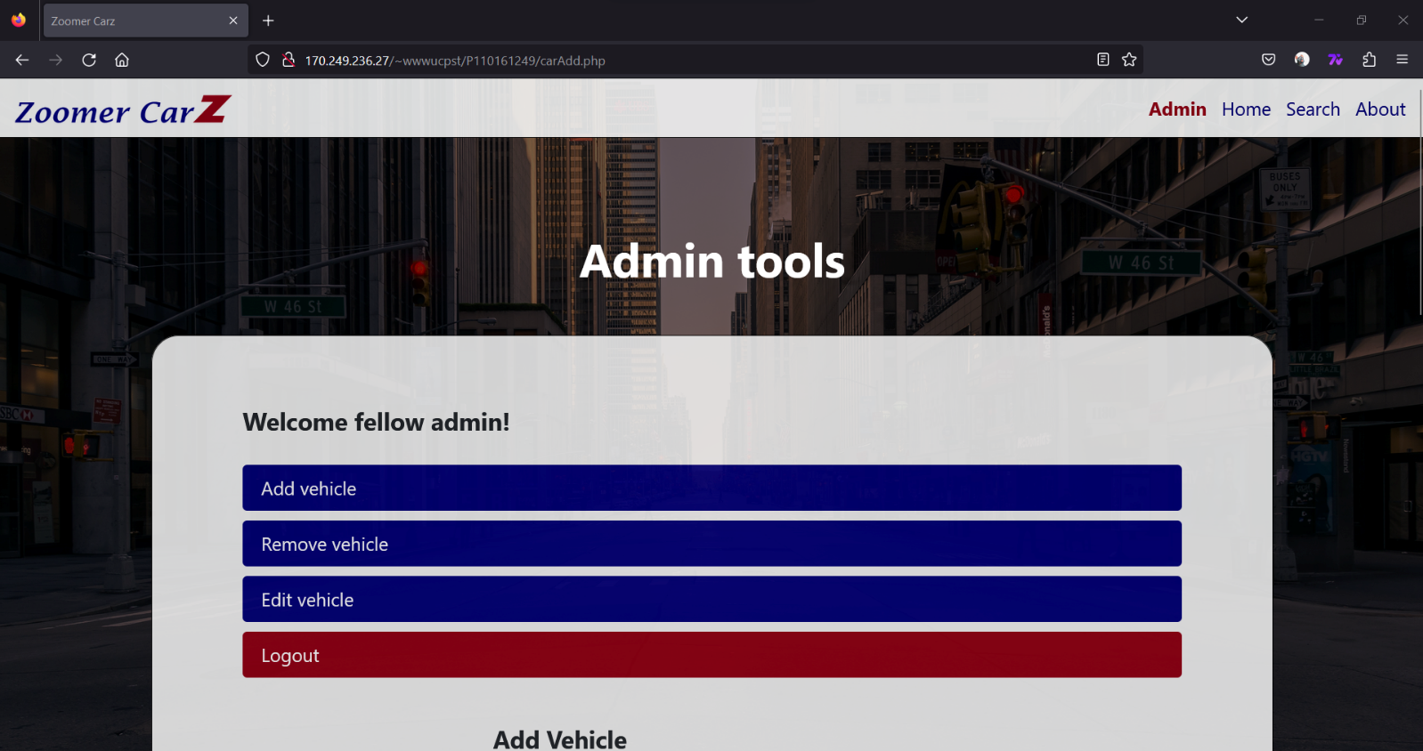

**Figure 13.** An image to show the second portion of the add vehicle page on a Mozilla Firefox browser.

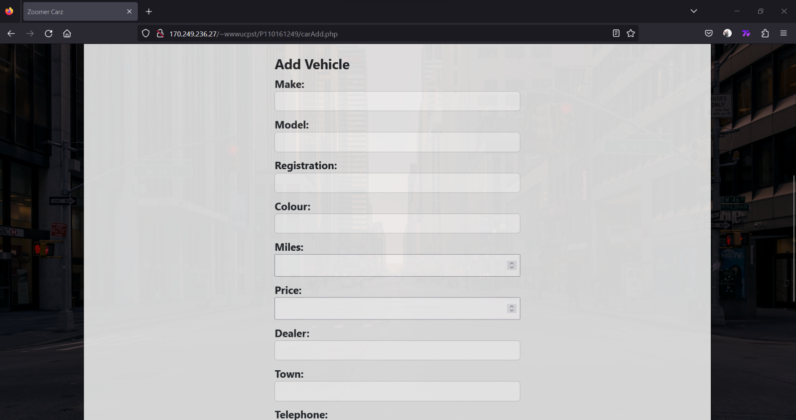

**Figure 14.** An image to show the final portion of the admin add vehicle page. Loaded on a Mozilla Firefox browser.

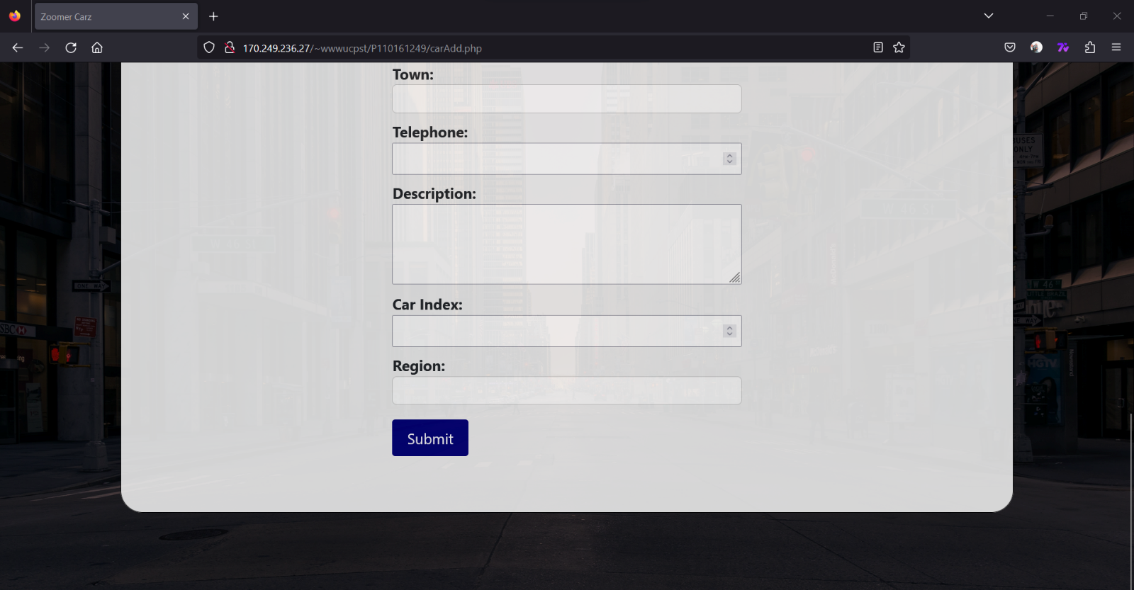

**Remove Vehicle**

The remove vehicle provides an index search option which the admins can use to find the vehicle they wish to remove. Once a vehicle is found, its details are displayed and there is a delete button at the bottom of the page for deletion.

**Figure 15.** An image to show the car index search for the remove vehicle page. Loaded on a Mozilla Firefox browser.

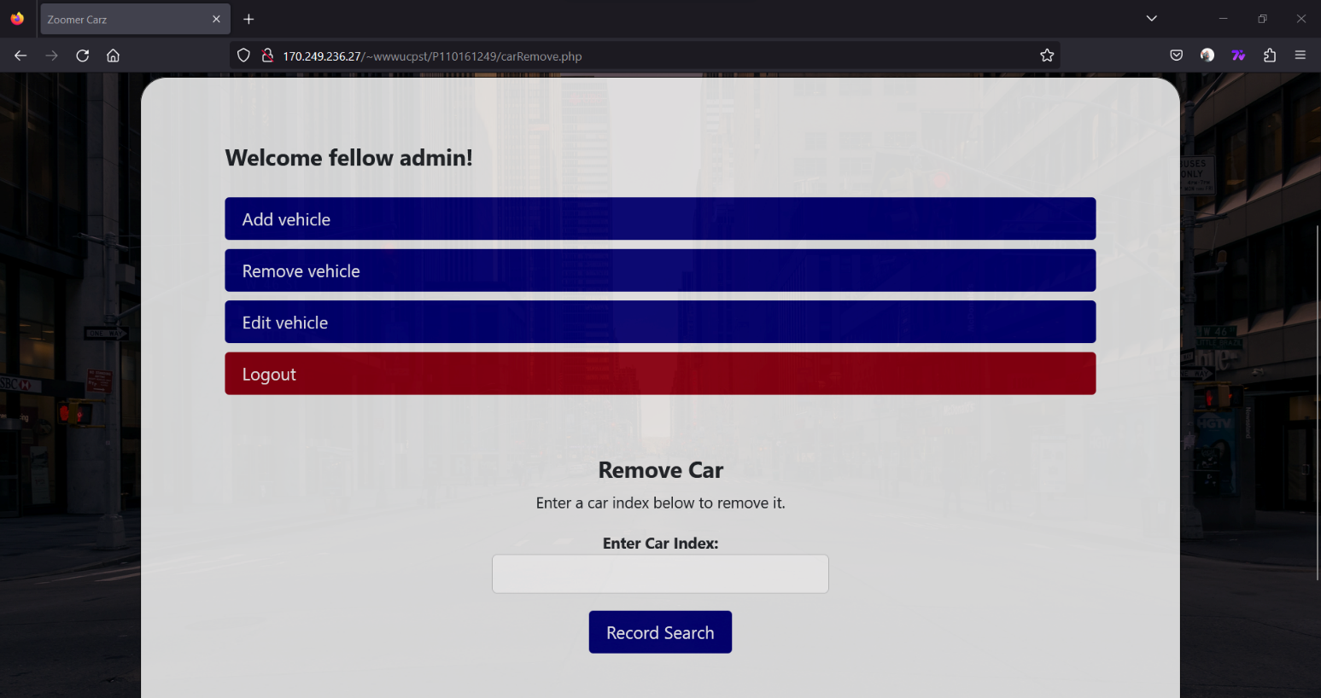

**Figure 16.** An image to show the first potion of the remove vehicle page once an index has been searched for. Loaded on a Mozilla Firefox browser.

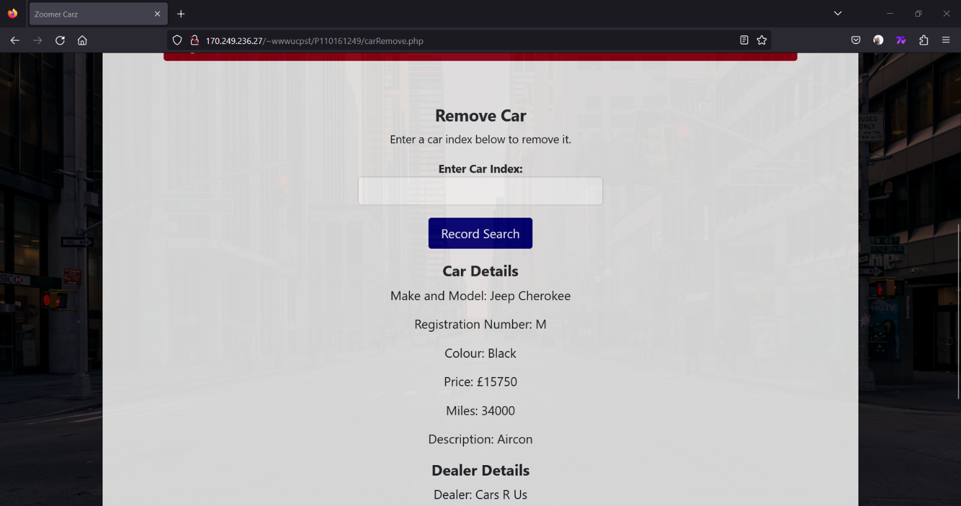

**Figure 17.** An image to show the second potion of the remove vehicle page once an index has been searched for. Loaded on a Mozilla Firefox browser.

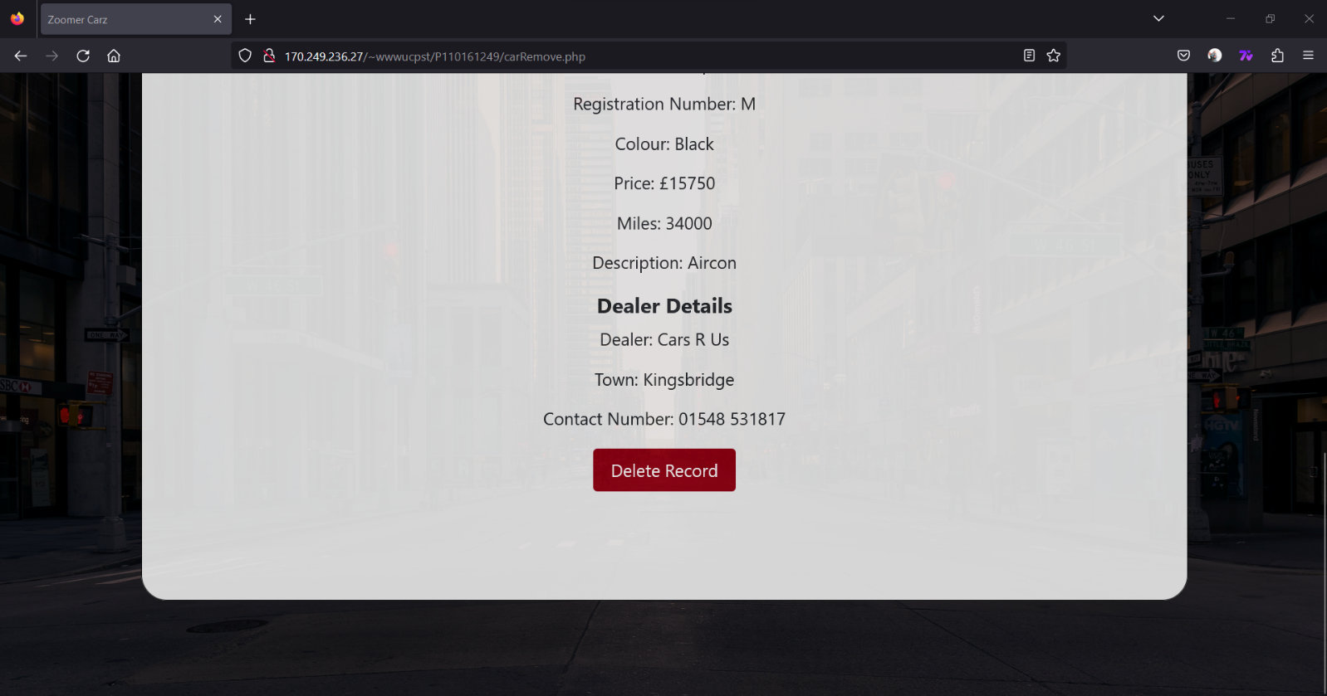

**Edit Vehicle**

The edit vehicle page works similarly to the remove vehicle page, the admin selects the index of the vehicle they would like to edit. The admin is then presented with a form of vehicle details pre-filled with the existing vehicle details and a button at the bottom of the page to submit their edits to the database.

**Figure 18.** An image to show the car index search for the edit vehicle page. Loaded on a Mozilla Firefox browser.

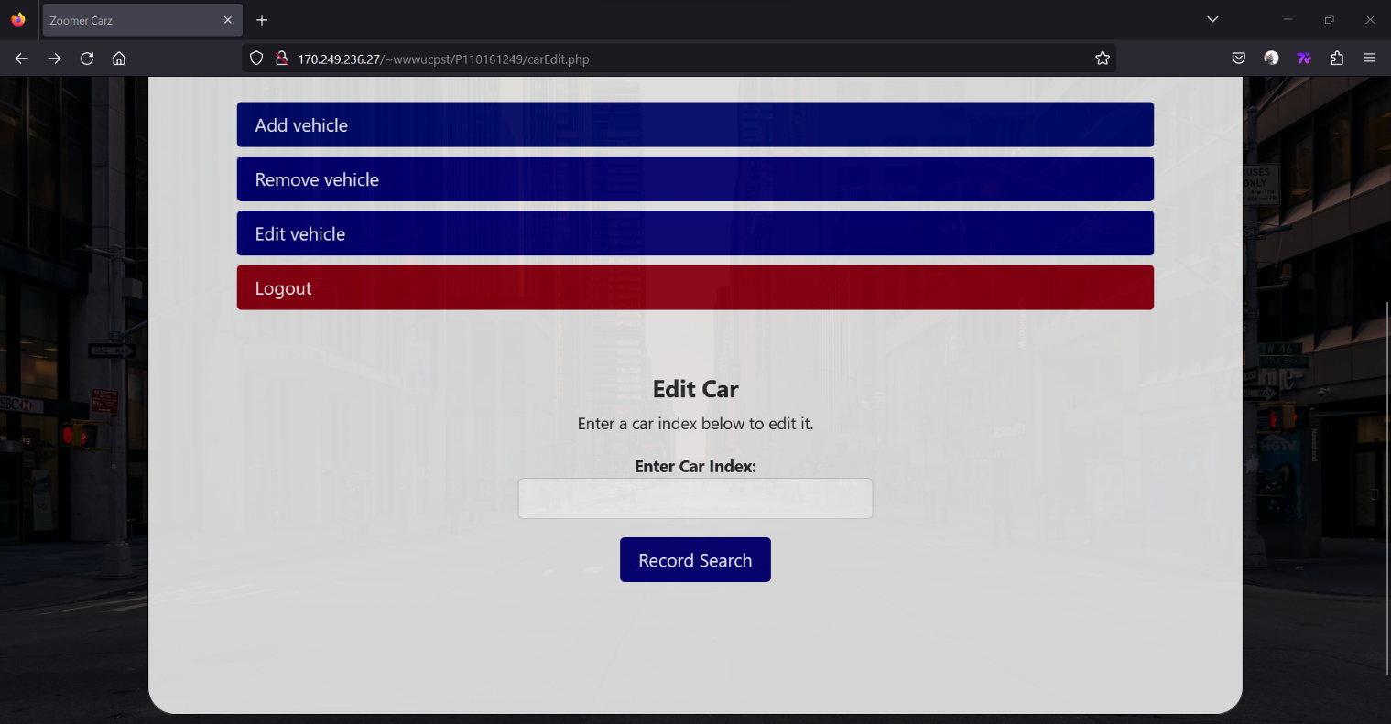

**Figure 19.** An image to show the first potion of the edit vehicle page once an index has been searched for. Loaded on a Mozilla Firefox browser.

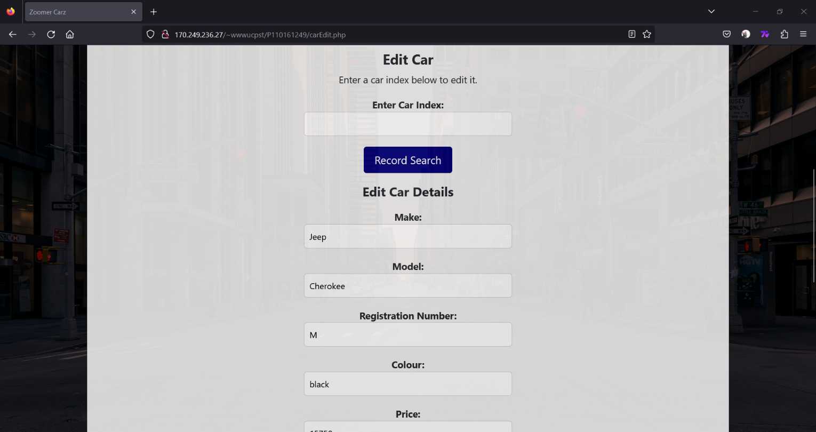

**Figure 20.** An image to show the second potion of the edit vehicle page once an index has been searched for. Loaded on a Mozilla Firefox browser.

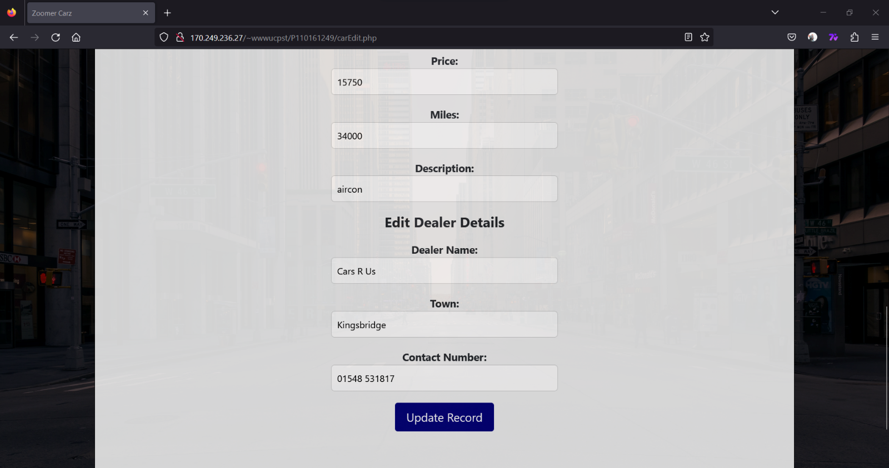

**Page structure/hierarchy diagram**

**Figure 21.** An image to show the hierarchy diagram for the website.

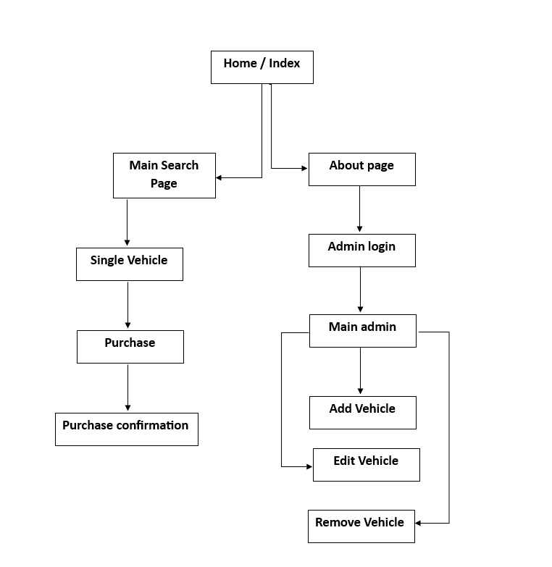

**Data Dictionary**

Only one database was used for this website. The database is called cars and contains one table called cars.

**Figure 22.** An image to show the data dictionary for the cars database.

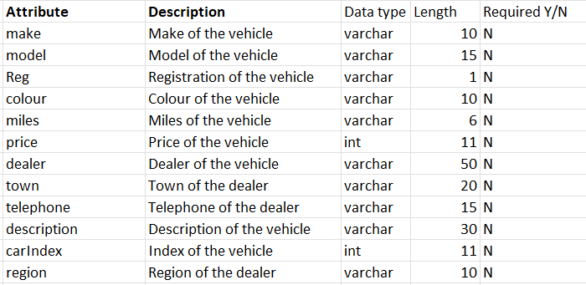

**Process Descriptions**

**Main Search Page**

The php application connect to the database and carries out some connection checks once complete. The code application then works out pagination, total cars that apply for the filter applied, the ordering of the data and the queries associated with these processes. The application then echos the results and the pagination content.

**Single Vehicle**

The application connects to the database and carries out some connection checks once complete. It then gets the ID from the previous main search page, fetches the data associated with the ID and presents the data for the vehicle.

**Admin login**

The application checks if the user is signed in, checks for form post submissions, if there is a post submission matching credible login details, the page redirects to the main admin page, else it prompts an error message.

**Add Vehicle**

The application checks if the user is logged in, connects to the database, checks for a post from the form. Based on those details it then prepares a SQL statement, binds parameters to the statement and then executes the statement to add a vehicle. There is then a small check to see if everything worked and a message to state the status of the request.

**Remove Vehicle**

The application checks if the user is logged in, connects to the SQL database. The application then fetches car details for the selected vehicle index in the index search. If the record exists, the application displays all the data relevant to the vehicle. The application also checks whether the delete button was clicked, in which case the application reconnects to the database and deletes the index selected.

**Edit Vehicle**

The application starts with checking the login state, checks if the search index button was clicked for the remove vehicle tool. If the button was clicked, the application connects to the database, fetches vehicle details for the selected vehicle index and displays the results if they exist. Just like the remove vehicle button, the edit vehicle application looks whether the button was clicked, in which case the application updates the records based on the content entered by the user and sends it to the database for processing. It prompts a status message and closes the database connection.

**Important sample code**

**Figure 22.** An image to show some of the core code for working out results and pagination preparation.

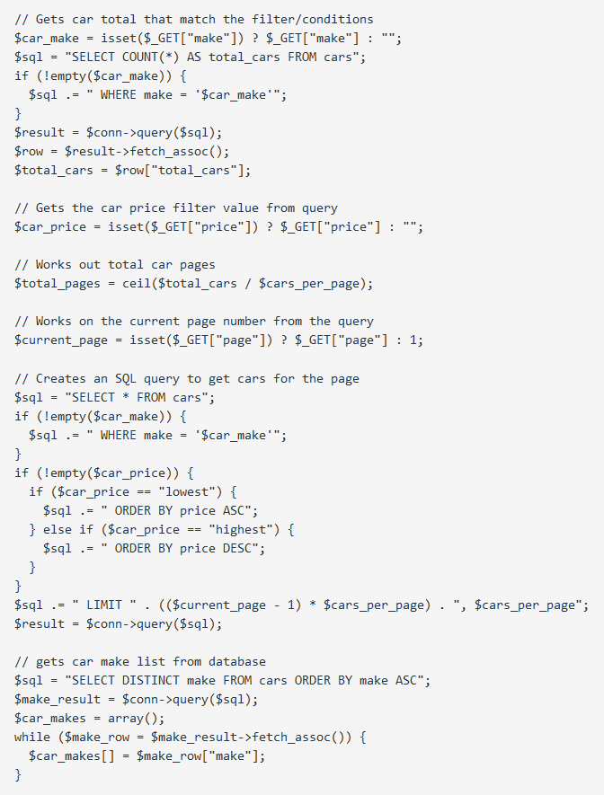

**Figure 23**. An image to show the main vehicle search page’s pagination logic.

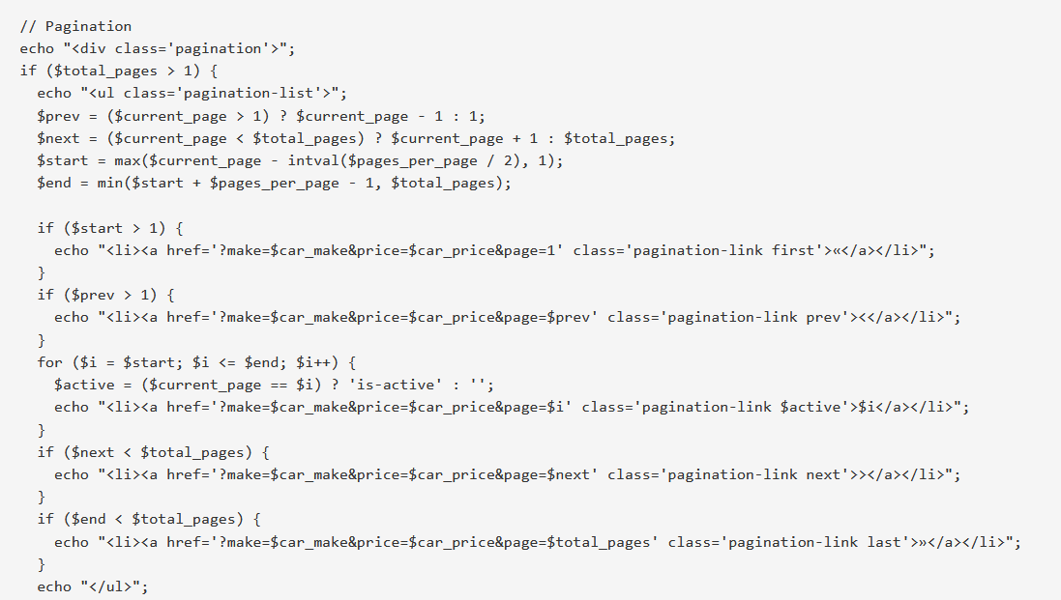

**Testing**

Testing plays a crucial role in ensuring a website's functionality and optimal performance. Throughout the development process, a comprehensive testing approach involving Selenium, Chrome Lighthouse testing, and user feedback was employed. The tests confirmed that the website operates as intended, with seamless navigation, functional elements, and a visually pleasing interface that garnered overall user satisfaction.

However, during the Lighthouse testing phase, certain areas for improvement were identified. These primarily focused on code practices, formatting, image sizes and using HTTPS. It is important to note that the limited use of images throughout the website contributed to the minimal impact of these issues.

**Figure 24.** An image to show the Lighthouse test results for the allCars page / the main car search page. There was an assumption that due to the larger sum of code and functionality within the page, that it would be slower but that turned out to be false.

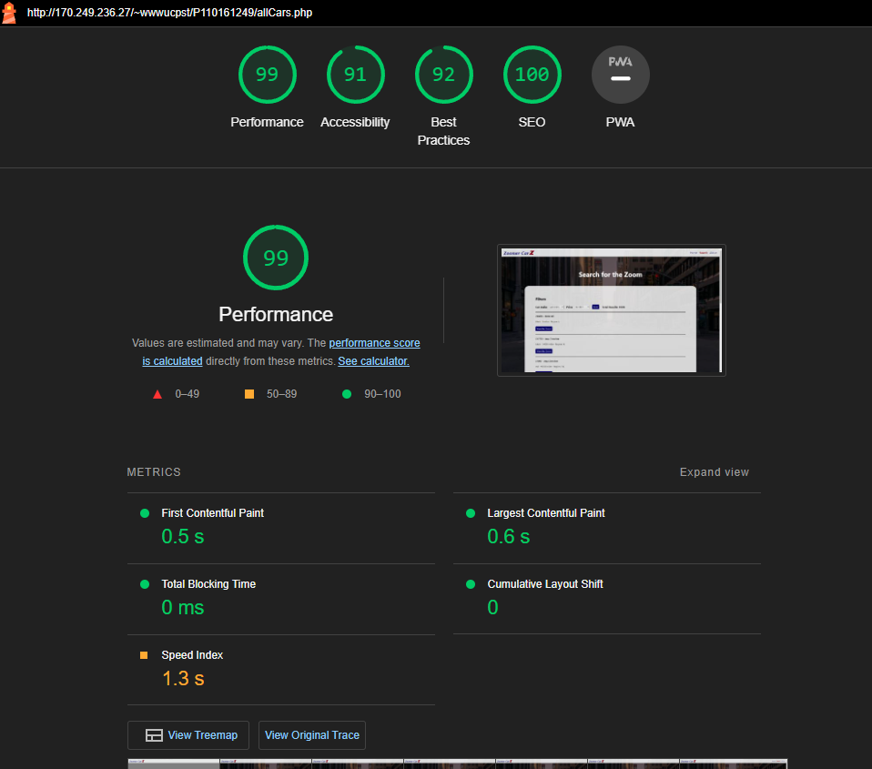

**Figure 25.** An image to show the Lighthouse test results from the vehicle record edit page. It was also expected for this page to function slower due to the complexity of the code within but just like the previous assumption that was false. Yet again, the only downfall of the of the code was best practices and accessibility.

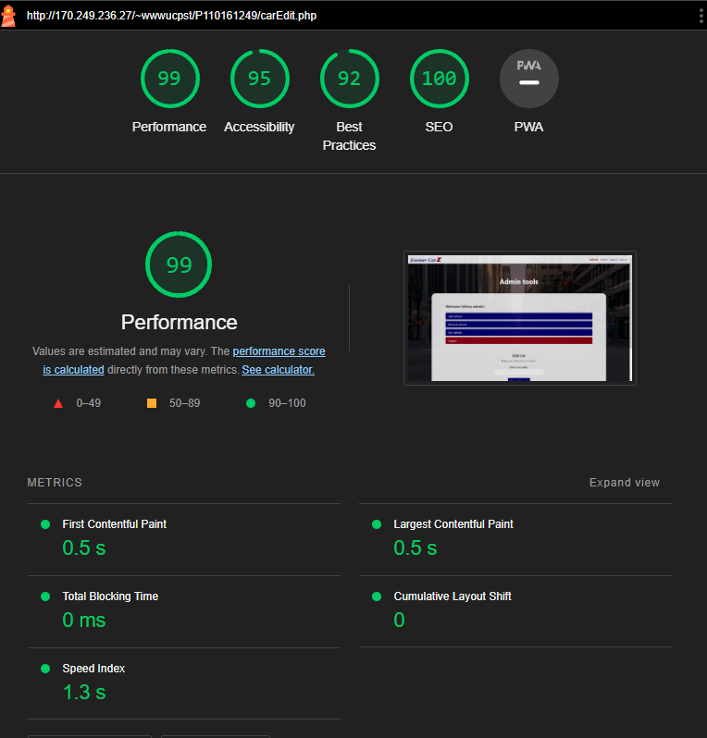

**Figure 26.** An image to show the Lighthouse test’s best practices section for the vehicle edit page.

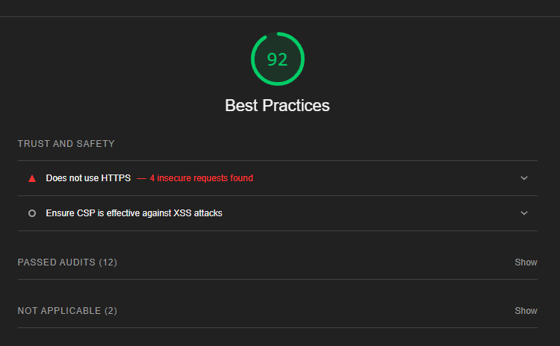

**Figure 27.** An image to show the Lighthouse test's accessibility section for the vehicle edit page.

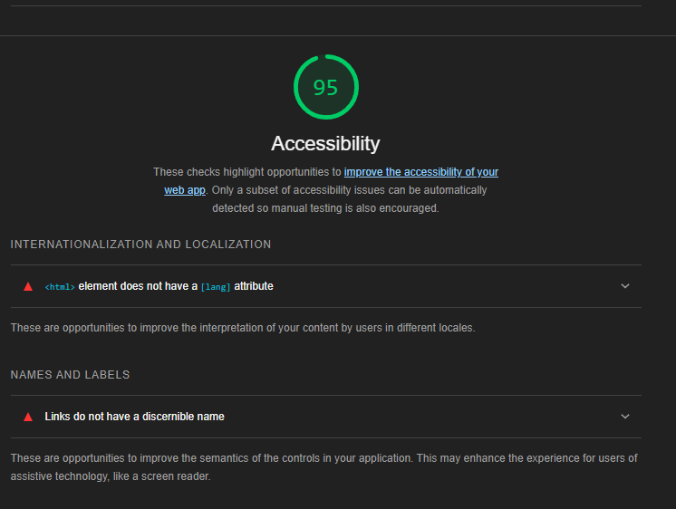

**References**

Scacca, S. (2018) *A Reference Guide For Typography In Mobile Web Design — Smashing Magazine* [Online]. Available at https://www.smashingmagazine.com/2018/06/reference-guide-typography-mobile-web-design/ (Accessed 1 May 2023).

Gordon, K. (2020) *5 Principles of Visual Design in UX* [Online]. Available at https://www.nngroup.com/articles/principles-visual-design/ (Accessed 1 May 2023).

‌

‌

‌